Day 24 - 06th Aug 2025

Design patters:
- Creational Design Patterns:
types of Creational design Patterns:
- Factory Method
- Singleton Method
- Abstract Factory Method
- Builder Method
- Prototype Method

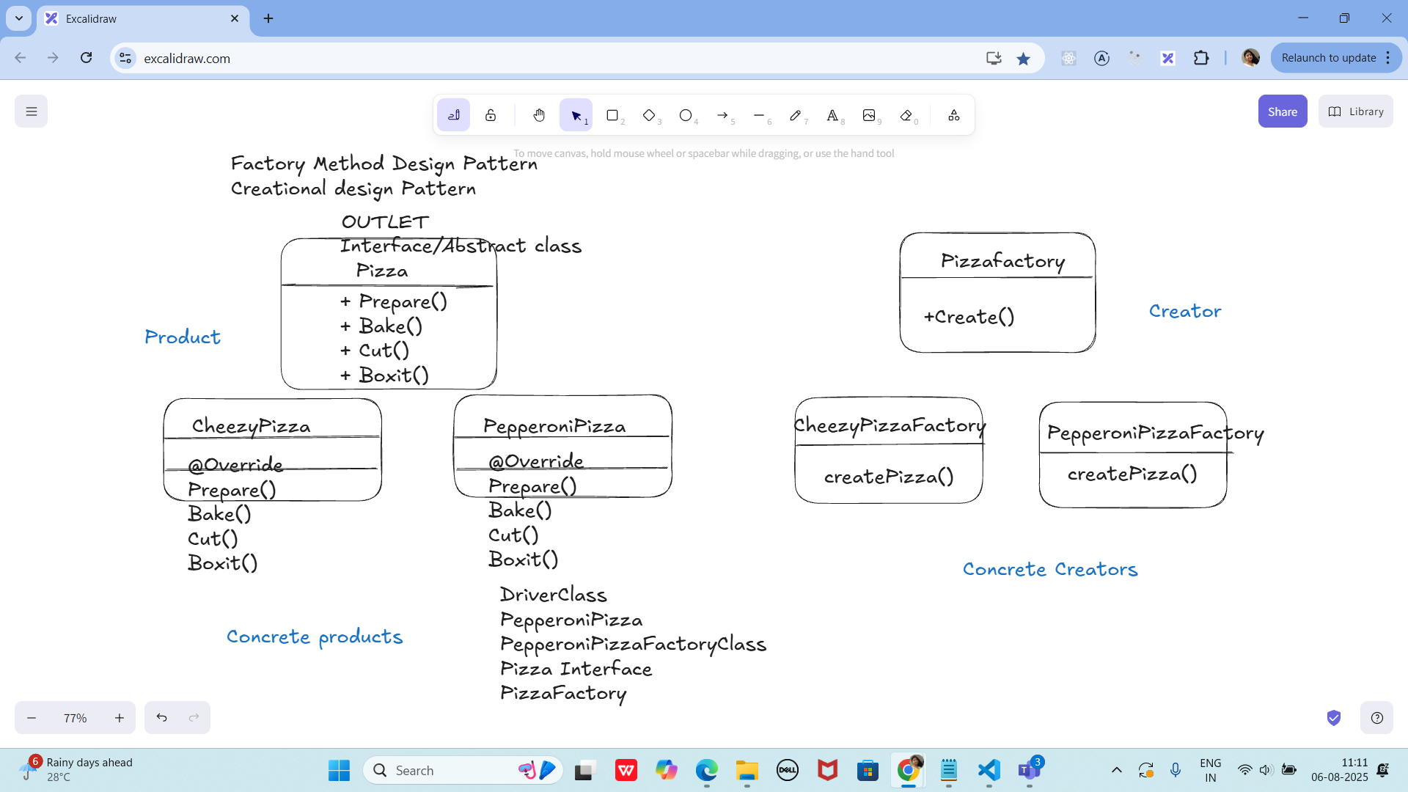

Task 01:

On the basis of above SS try to create a factory Method Design Pattern program
Solution:

package Design_Patterns.CreationalDesignPattern;

public class FactoryMethodDPattern {
public static void main(String[] args) {
PizzaFactory pizzaFactory = new PepperoniPizzaFactory();
Pizza pizza = pizzaFactory.cretePizza();
}
}

package Design_Patterns.CreationalDesignPattern;
//concrete Product
class PepparoniPizza implements Pizza{
void Prepare() {
System.out.println("preparing product pizza");
}
void bake() {
System.out.println("baking product pizza");
}
void cut() {
System.out.println("cutting product pizza");
}
void boxIt() {
System.out.println("boxing product pizza" );
}
}

package Design_Patterns.CreationalDesignPattern;

public class PepperoniPizzaFactory implements PizzaFactory {
@Override
public Pizza cretePizza() {
return new PepparoniPizza();
}
}

package Design_Patterns.CreationalDesignPattern;
//Product Interface
public interface Pizza {
void Prepare();
void bake();
void cut();
void boxIt();
}

package Design_Patterns.CreationalDesignPattern;

public interface PizzaFactory {
Pizza cretePizza();
}

Singleton

Task 02:

package Demo_Codes.Module;
import java.io.IOException;
import java.io.InputStream;
import java.util.Properties;
public class SingletonDPConfigManager {
private static SingletonDPConfigManager ConfigManagerInstance;
private Properties properties;
private SingletonDPConfigManager() {
properties = new Properties();
try (InputStream input = getClass().getClassLoader().getResourceAsStream("config.prop")) {
if (input == null) {
System.out.println("we cant find config properties"); // error
return;
}
properties.load(input);
}catch (IOException ioexp) {
ioexp.printStackTrace();
}
}
public String getProperty(String key) {
return properties.getProperty(key);
}
public static synchronized SingletonDPConfigManager getConfigManagerInstance() {
if (ConfigManagerInstance == null) {
ConfigManagerInstance = new SingletonDPConfigManager();
}
return ConfigManagerInstance;
}
}

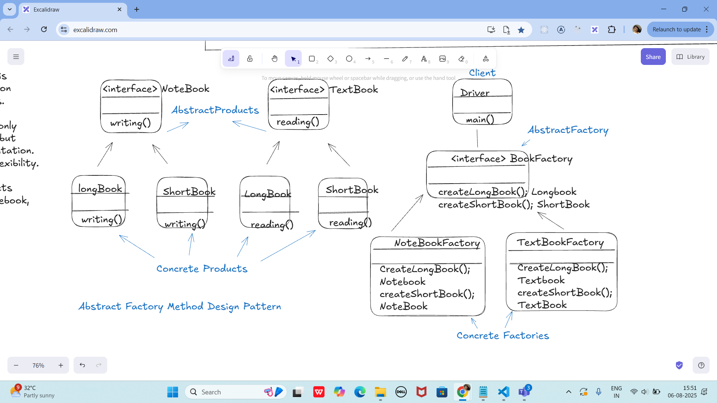

Task 03:
Abstract Fcatory Method Design pattern

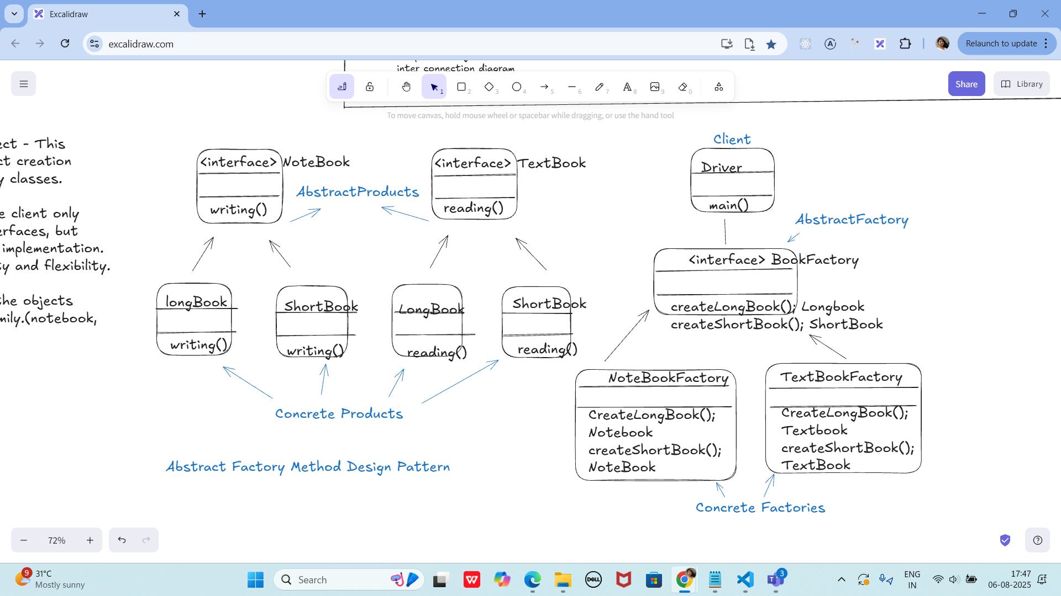

Write a code for the above implementation

Task 04:

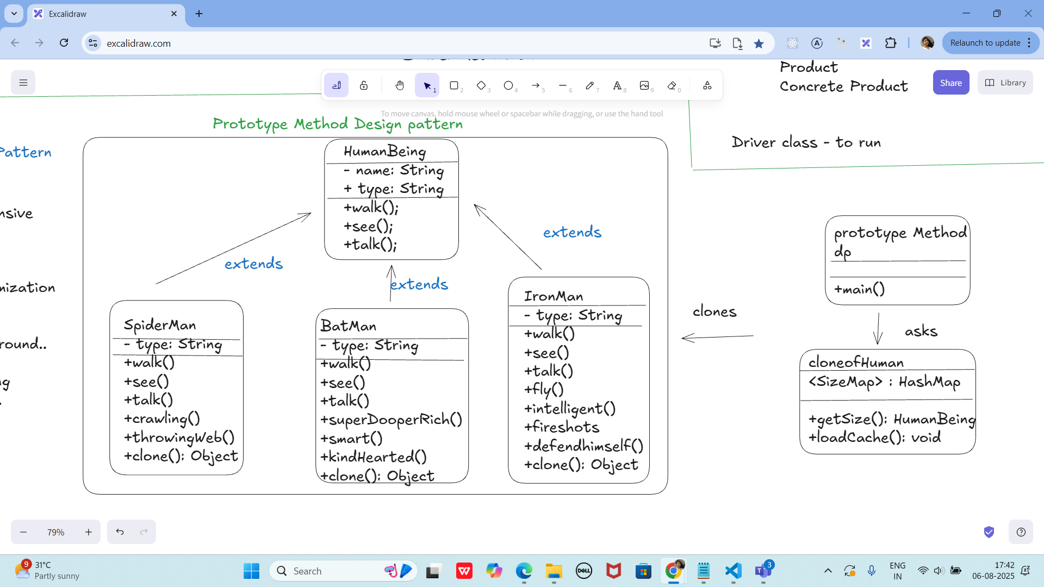

Write a code for the above implementation

Clone method for your reference..

public abstract class HumanBeing implements Cloneable { ........walk, see......()
public Object clone() {
Object clone = null;

try {
clone = super.clone();
}catch (CloneNotSupportedException ex) {
ex.printStacktrace();
}
return clone;
}

Task 05:

@startuml
participant Pax as p
actor Actor as a #Green
boundary Boundary as b
control C as c
database Dbase as db
entity table as t
collections col as c
queue que as q

autonumber
p -[#red]> a : pax to actor
a ->x p: ohh is it!
autonumber 100
b ->> p: boundary to pax
note left: plz make a note on left
c -\ p: control to pax
db \\- p: db to pax
autonumber 50 10
t //-- db: table to db
c ->o db: collection to db
note right: plz make a note
q <->o p: q to pax

Prasunamba -> Batch1 : learning uml
Batch1 -> Prasunamba: ok will learn
@enduml
Excalidraw doc - updated as of 06th Aug 2025 at 12.55.

https://excalidraw.com/#json=lNVBffaZ5rqFz0EguLS2O,Q045iriTq36O-xpkRuMALw

Batch 1 search for ..

Excalidraw updated at 15.52

https://excalidraw.com/#json=sgLnZ1LgJmQvx9mLT9aVs,dlgTINtAnvkOhqJni9kqMQ

Excladraw updated at 17.49

https://excalidraw.com/#json=c9ba8a3aKVCjfyn4V3NFa,hw4gAybtOZhPReHzvTh-1A

++++++++++++++++++++++++++++++++++++++++++++++++++++++++++++++++++++++++++++++++++++++++++++++++++++++++++++++++++++++++++++++++++++++++++++

